UFR NANO TO RGB MODULES CONNECTION
VERSION 1.0
Table of Contents
NANO UFR CONNECTION WITH RGB MODULES 3
Revision history 5

NANO UFR CONNECTION WITH RGB MODULES
Nano uFR reader can be connected with RGB modules.
For that purpose, are used 3 pins on the board.
They are:
+5V
DOUT
GND
Position of pins is shown in the following figure
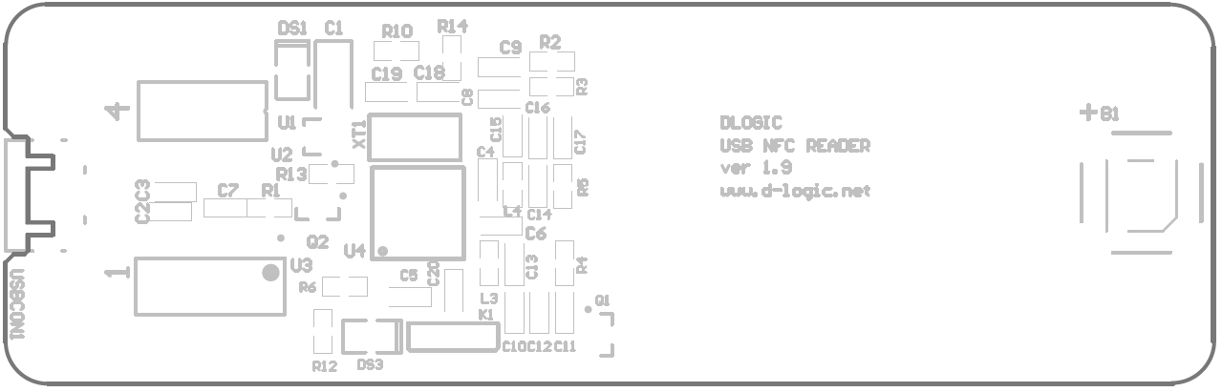
DOUT
+5V
GND
Schematic is shown in the following figure

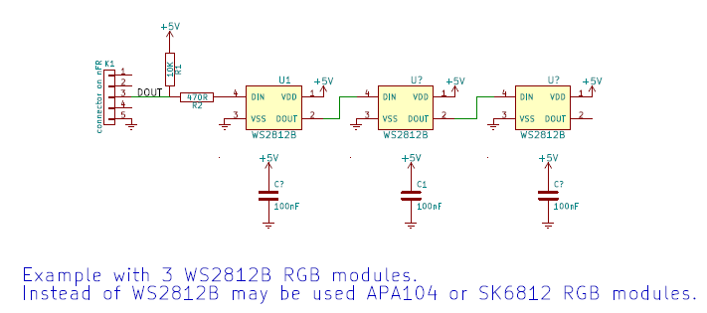

Revision history
Date | Version | Comment
2016-11-16 | 1.0 | Base document

